Label the Laptop Motherboard Components

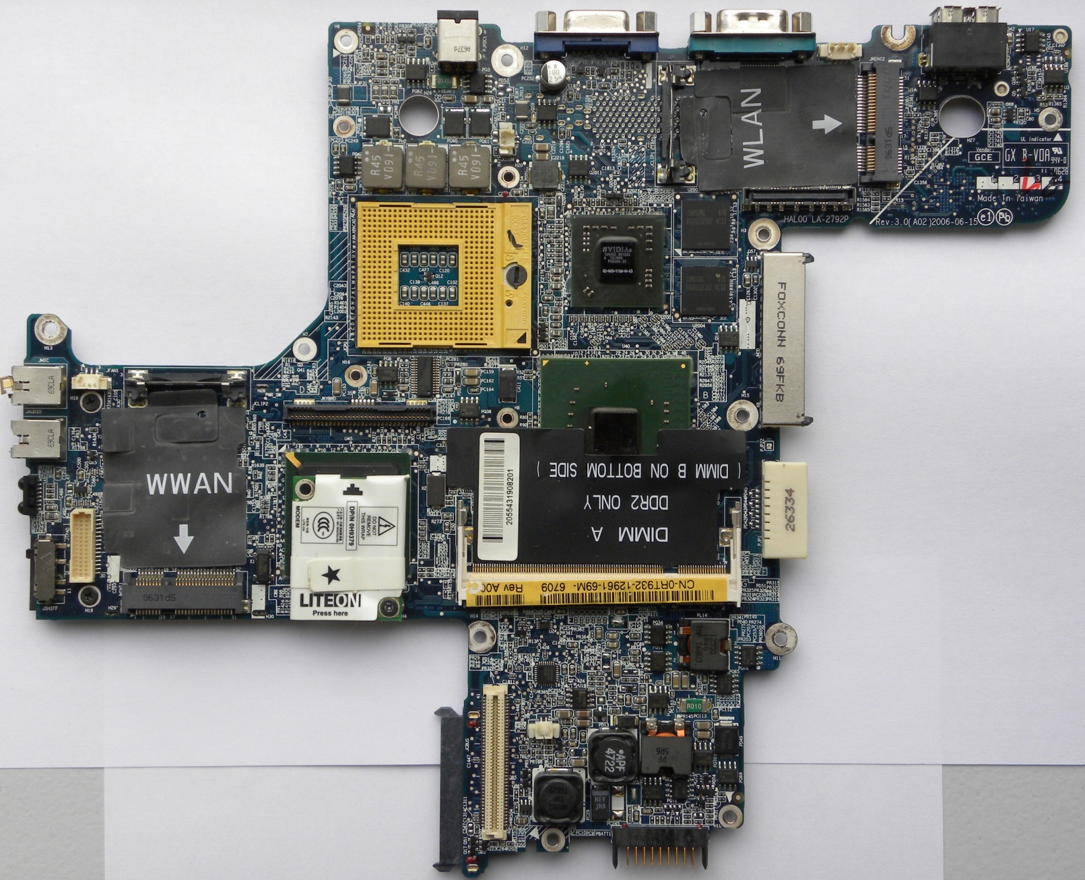
Objective: Identify and enter the name of each of the marked components into the text boxes. You may use the internet for this assignment.
(Under the LiteOn Modem)

